Report to the Executive Director for Place

Application for a Definitive Map and Statement Modification Order to upgrade Bridleway 1, Winterbourne Abbas to Byway Open to All Traffic.

For Decision
Portfolio Holder: Cllr D Walsh, Planning

Local Councillor(s): Cllr Roland Tarr
Executive Director: J Sellgren, Executive Director of Place

Report Author: Barbara Talbott
Title: Definitive Map Technical Officer
Tel: 01305 225706
Email: barbara.talbott@dorsetcouncil.gov.uk

Report Status: Public

Brief Summary:
This report considers an application for a Definitive Map Modification Order, based on historic evidence, to upgrade Bridleway 1, Winterbourne Abbas (Copyhold Lane) to Byway Open to All Traffic. Following an investigation of the documentary evidence, a recommendation is made to approve part of the application.

Recommendation:
That:
- The application be refused:
- An order be made to modify the definitive map and statement of public rights of way to record part of Bridleway 1, Winterbourne Abbas as shown A-B-C-D on Drawing T390/23/2 as a restricted byway;
(c) If the Order is unopposed, or if any objections are withdrawn, it be confirmed as made by the Council.

Reason for Recommendation:

- Subject to (b) below, the claimed Byway Open to All Traffic does not subsist, nor can be reasonably alleged to subsist;
- The available evidence shows, on balance, that a highway shown on the definitive map and statement as a Bridleway between points A-B-C-D on Drawing T390/23/2 ought to be shown as a Byway Open to all Traffic. However, the provisions of the Natural Environment and Rural Communities Act 2006 extinguished the public rights for mechanically propelled vehicles and therefore an order should be made for a restricted byway over that part of the claimed route; and
- The evidence shows, on balance, that part of the route claimed is a restricted byway. Accordingly, in the absence of objections, Dorset Council can itself confirm the Order without submission to the Planning Inspectorate.
- Background
Applicant
- On 10 September 2005 FoDROW (Friends of Dorset Rights of Way) submitted an application to upgrade the entire length of bridleway 1, Winterbourne Abbas, to a Byway Open to All Traffic, based on historical evidence. On 04 October 2010, the applicant formally changed to the Trail Riders Fellowship (TRF).
Description of the route
- The claimed route follows the entire route of Bridleway 1, Winterbourne Abbas known as Copyhold Lane.
- The claimed route commences at a point on the A35 trunk road where Copyhold Lane is identified by an official name board (Point A). The width on the ground at this point is approximately 7 metres.
- The route runs in a northerly direction for approximately 163 metres, where a locked field gate is installed (Point B), adjacent to the Midway Business Park. The width at this point is approximately 7.5metres (hedge to hedge).
- The route then turns north-west for a distance of approximately 1575 metres (Points B-C-D), the hedge-to-hedge width remains at a constant 30ft (9metres) between points B and F, with a useable width of track of 15ft (4.5metres)
- At point D, the route continues in a north-westerly direction for a further 524 metres, with an approximate width on the ground of 1 metre. The route ends at point F where it meets the D class (Roman) road at a point west of Higher Hogleaze Farm.
- Between points A-B-C-D-E the route has a rubble stone surface.
- Between points E-F, the route runs across an arable field, is not fenced or waymarked from the south.
Use of Evidence
- The applicant submitted historical documentary evidence in support of this application.

- A wider selection of documentary evidence has been researched from sources such as the Dorset History Centre and the National Archives, Kew.
- A full consultation exercise was carried out between 16 June – 11 August 2023 which included landowners, user groups, statutory consultees, the parish council, those affected and anyone who had already contacted Dorset Council regarding this application.

- The Councillor for Winterbourne Abbas, Cllr Roland Tarr, (Winterbourne & Broadmayne Ward), and Winterbourne Abbas Parish Council was notified during this consultation exercise.

- In addition, notices with coloured map explaining the application were erected on site on 15 June 2023.

- Law
  - A summary of the law is contained in Appendix 2.

- Issue to be decided
  - The issue to be decided is whether there is evidence to show, on the balance of probabilities, that the status of the route should be recorded with higher public rights than currently exist. It is not necessary for evidence to be ‘beyond reasonable doubt’ before a change to the Definitive Map can be made.
  - Any changes to the Definitive Map must reflect public rights that already exist. Decisions must not be taken for reasons of desirability or suitability. Before an Order changing the Definitive Map is made, the Council must be satisfied that public rights have come into being at some time in the past. This might be demonstrated by documentary evidence and/or witness evidence.
  - Historical documentary evidence has been examined to determine whether depictions of the route point to it having acquired higher public rights of the status claimed (ie Byway Open to All Traffic) in the past. Any such rights are not lost through disuse.
  - Unless stopped up by due process of law, any rights previously dedicated will still exist even if they are no longer used or needed.
  - It is unlikely that a single map or document will provide sufficient evidence to justify a change to the Definitive Map; the evidence must be assessed holistically.
  - The Council has a duty to record any rights that are found to subsist even if they are not those claimed by the applicant.
  - No user evidence is available for scrutiny in this case. The application relies solely on the historic documentary evidence.
  - For the assessment of this application, the provisions of the NERC (National Environment and Rural Communities) Act 2006 will be applicable in the determination of the status of the route.
- Documentary evidence (Appendix 3) (copies available in the case file RW/T390)
- A table of all the documentary evidence considered during this investigation is contained in the case file. All documents considered relevant are discussed below. Information on the background and evidential weight which should be attached to particular historical sources is included under the relevant headings below.
Taylor Map 1765
- Isaac Taylor (1730-1807) was the first map maker to produce a large-scale map of the county of Dorset, at a scale of one inch to the mile. The map is recognised as having various inaccuracies, such as incorrect place names.
In the Winterbourne Abbas area, Taylor’s map shows the claimed route in its entirety as a public carriage road, surfaced, and fenced on both sides.
Officer comment: The depiction on this map of the claimed route as a public carriage road supports the other historical evidence discovered.
Inclosure Award and Map 1808
- The 1808 Inclosure Award and Map for the Winterbourne Abbas area does not cover the geographic area of the claimed route, save for a reference to Copyhold Lane, both in the text transcript, and also marked on the map.
- The Award describes how the public carriage road and highway of the breadth of 30ft known as Beacon Road, marked ‘E’ on the Inclosure map begins ‘at a gate leading from Compton Valence and Maiden Newton to the entrance of the lane called Copyhold Lane in Winterbourne Abbas’. The Map shows this gate and a short section of Copyhold Lane leading east (extract provided in Appendix 3 of this report).
- Officer comment: Comparison with other maps of the time confirms that ‘Beacon Road’ did in fact lead eastwards to the route known as Copyhold Lane. Copyhold Lane then continued southwards to the village of Winterbourne Abbas. The Tithe Map and apportionment (described below – paragraphs 4.18-4.33) provides a greater understanding of the historic classifications of each of the roads in and around Winterbourne Abbas.
- Comparison of the Inclosure Award map with modern day maps (see Appendix 3) shows that the ‘private carriage roads’ described in the Inclosure Award are no longer in physical existence on the ground or shown on maps. Copyhold Lane itself is, however, clearly shown on commercial and ordnance survey maps to the present day.
- It was a requirement for the Inclosure Award surveyor to accurately record the status of a way at the time of the Inclosure survey (for which the primary purpose was the reorganisation of the land for each parish), and it was crucial that accurate measurements were made. Copyhold Lane was described in the Award and shown on the Map. Accordingly, this accuracy can be ascribed to the ways on the ground which the Commissioners surveyed and recorded, which in turn assists in the contemporary interpretation of the existence of routes used by the public in the locality of the route in question.
Mudge Map 1817
- In March 1798, Captain William Mudge was appointed ‘Superintendant and Director of the Trigonometrical Survey’ - “a body charged with conducting a nationwide triangulation that would underpin a new, pioneeringly accurate topographic map of the United Kingdom”.
- The map for Dorsetshire was published in 1817. No scale is printed on the map, but it appears to be one inch to the mile, comparing with maps of known scale.
- The entire claimed route A-B-C-D-E-F is shown on this historic map as one continuous route, leading north and north-west. It is shown with solid lines both sides of the track up to point ‘D’, in the same manner as other known public highways (see Appendix 3). From point ‘D’ the route is shown with a double pecked line, indicating it was unfenced.
- No footpaths were shown on this map, just carriageways.
Greenwoods Map 1826
- Two brothers, Christopher and James Greenwood were surveyors working in the 19th century. They compiled and published large scale maps of most of the counties of England during the years 1817-1831.
- The Greenwoods’ mapping was an expensive project designed to appeal to country gentlemen and covered 34 counties in England. The maps record the state of the respective county (surveyed in great detail) at the height of the coach and canal era. Many features are shown including watermills, windmills, estates – both large and small, turnpike roads, and milestones, antiquities, and industrial sites. These maps were known for their accuracy and detail.
- The mapping covering Dorset is dated 1826. The map section around Winterbourne Abbas clearly shows the entire route as claimed; it leaves the major road (now the A35) at point A, travelling north to point B, thence north-west to points C, D, E and F.
- The route is shown with double solid lines (indicating the route was fenced), drawn in the same manner in which other known public roads are depicted at this time, between points A-B-C-D.
- Between points D-E-F, the route continues, drawn with double pecked lines indicating the route was unfenced.
- Officer comment: These maps were drawn specifically to be purchased by country gentlemen, likely intended for them to follow routes on which to drive their horse and carriage. The map-makers are unlikely to have shown routes which could not have been utilised by the purchasers of the maps.
Tithe Map 1840
- The Tithe Commutation Act of 1836 enabled tithes (literally a tenth of the produce of the land) to be converted to a monetary payment system.
- Maps were drawn up to show the tithable land, so that the amount of money to be paid could be assessed. The Act was amended in 1837 to allow maps produced to be either first class or second class.
- First class maps are legal evidence of all matters which they portray and were signed and sealed by the commissioners (Tithes Act 1847). They had to be at a scale of at least 3 chains to the inch.
- Second class maps, signed but not sealed, were evidence only of those facts of direct relevance to tithe commutation, and are often at 6 chains to the inch. There was a proposed convention of signs and symbols to be used which included Bridle Roads and Footpaths, but this was not strictly adhered to.
- The tithe process received a high level of publicity. Landowners would be particularly keen not to be assessed for more tithe payment than necessary.
- Non-tithable land deemed to be unproductive was usually excluded from the process. It is common therefore for no tithe to be payable on roads, although wide grass drovers’ routes could carry a tithe as they were used as pasture.
- It was in the interest of the landowners for un-tithed roads to be shown correctly to minimise their payments. Footpaths and bridleways (like drove roads) were more likely to be at least partially productive for pasture.
- Although the tithe process was not directly concerned with rights of way, inferences can be drawn from tithe documents concerning the existence of public rights over land.
- The Winterbourne Abbas Tithe Map and Award of 1840 covers the wider area in which the claimed route is located. The southern section of the application route (A-B-C-D) is shown on the Tithe Map annotated as apportionment ‘172’.
- The Tithe Award includes a section entitled “Name and Description of Lands and Premises”, within which has been written the title ‘Roads, Driftways, and Waste’. Apportionment number 172 is included within this section. The column entitled ‘Rent Charge’ for all the entries within this section is blank, ie no tithe was charged on any land considered by the surveyors to be a Road, a Driftway, or waste land (points A-B-C-D).
- At the centre of the claimed route (point D), apportionment number 172 turns westwards and joins with apportionment number 88. This land is also included within the same ‘Roads, Driftways, and Waste’ section and is described as a ‘driftway’. No rent charge is payable on this land.
- The Open Spaces Society note that “Land that was not subject to tithes was generally accepted to be public or owned by the church or crown estate”.
- The section of the claimed route marked D-E-F is not shown on the Tithe Map.
- Officer comment: No rent charge was payable on apportionments 172 or 88, and both are included in the section with other roads, indicating that the Tithe Commissioners at the time considered these plots of land were roadways for public use.
- Officer comment: The drafting style for the section of the route A-B-C-D with double solid lines either side of the route is shown in the same manner on other historic maps. It is clear that those professionals who surveyed this route (A-B-C-D) were in agreement that the route was fenced on both sides. The route travelling westwards at point D is shown as fenced on the northern side only.
- Officer comment: The lack of an indication of part of the claimed route D-E-F on the map or in the award can be interpreted as the Commissioners not recognising that this northern section formed any part of a public route.
Bacon’s maps (c.1895)
- GW Bacon was a 17th century entrepreneur who turned his hand to map making. He made a number of different maps, covering various counties within the UK.
Bacon’s geographical map
- The application route is shown in full on this map between points A-B-C-D-E-F with parallel solid lines bounding the route. The map legend interprets this as a ‘Main and Cross road’. The drawn route runs south-west to West Chickerell, in the same manner as the earlier Greenwoods maps.
Bacon’s revised geographical map
- Again, this version of the map shows the application route in full, identified as an ’Other Road’ in the map legend.
- Officer comment: The showing of the application route as a Main/Cross/Other road in this manner on the Bacon series of maps is evidence that the route was considered to be in public use at the time. These maps were published for sale to the general public, and it is unlikely that any routes shown would be considered unsuitable for public use.
Finance Act 1910
- The Finance Act 1910 caused every property in England and Wales to be valued. The purpose was to charge a tax on any increase in value when the property was later sold or inherited.
- Although the valuation involved complicated calculations which are not relevant for highway purposes, two features do affect highways: i) Public vehicular roads were usually excluded from adjoining landholdings, and shown as ‘white roads’. ii) Discounts could be requested for land crossed by footpaths or bridleways.
- These facts are known, because s.35 of the 1910 Act provided that: “No duty under this Part of this Act shall be charged in respect of any land or interest in land held by or on behalf of a rating authority.”
- It is recognised that a highway authority was a rating authority.
- The section of the claimed route (A-B-C-D) is shown on the Ordnance Survey base map used for the 1910 Finance Act valuations held at the National Archives under document reference IR125/2/406. The claimed route is shown to lie within hereditament number 18 between points A-B and within hereditament number 30 further north.
- The central section of the claimed route (B-C) has no hereditament number assigned.
- The section D-E-F is shown on National Archives document reference IR125/2/401. This section lies within hereditament number 53.
- The usual style of annotations on the 1910 Finance Act Plans was to show a solid red line around the boundary of each individual hereditament, as shown in the extracts provided in the Appendices to this report. However, in the case of hereditament number 18, there are a number of locations on the map where roads cross the land within respective hereditaments, and which are annotated with a red dashed line where the road crosses through the numbered hereditaments.
- The dashed lines are annotated on ‘Copyhold Lane’ at (i) points B and D; and (ii) at a point partway between points C and D, where the hereditament number changes from 30 to an unnumbered hereditament. At point D there is also a solid red line denoting the southern boundary of hereditament 53 (part) through which the footpath/bridleway (D-E-F) passes (see paragraph 4.53).
- Investigation has revealed that this dashed line represents an intention of the cartographers that the road across which the dashed line is shown should be excluded from that particular hereditament’s overall acreage.
- The way known as ‘Copyhold Lane’ is shown with a dashed line at the points where it crosses hereditament numbers 18 and 30. Accordingly, it is therefore excluded from land tax payments (see paragraphs 4.38-4.40 above) and so would have been considered to be a public road.
- By way of comparison, the Old Turnpike Road to the south (now known as the A35) is shown with dashed lines across the road where a number of hereditaments span the road.
- Officer comment: With this analysis, it is clear that the section of the claimed route commencing at point A, and ending at point D was considered by the Commissioners to be a public road in nature.
- The Field Books associated with the 1910 Finance Act land value exercise are thorough in their assessment of each plot of land or hereditament. They provide a detailed description and value of the property, names the owner(s), identifies rents payable or paid on the land, and sets out any deductions considered necessary on the path, including the existence of any public rights of way.
- Each individual hereditament is set out separately over 4-5 pages in each respective Field Book. The text for hereditaments 18, 30 and 53 reveals that:
- Hereditament 18 shows no deductions for public rights of way
- Hereditament 30 shows no deductions for public rights of way
- Hereditament 53 shows a deduction of £125 for ‘Public Rights of Way or User’.
- Officer comment: There is only one identified public right of way in the combined detached parts of hereditament 53, and this is the section of the claimed route between points D-E-F. This section was therefore not considered by the Commissioners to be a public road as was the remainder of Copyhold Lane (points A-B-C-D).
- As described in the documentary evidence analysis for this application, Copyhold Lane (section A-B-C-D) is shown on a wide number of other printed plans as a public road.
HM Land Registry – Landowner Title documents
- Between points A-B of the application route, there is no land registered with the Land Registry.
- Between points B-C-D the land is shown to be split between two Titles: DT28043 and DT371778, with the latter appearing to cover the majority of Copyhold Lane.
- Both Titles are registered to be in the legal ownership of the same person.
- The claimed route between points B-E is included within the land of both of these legal Titles and is shown on the Title Plans. The section of the claimed route E-F is not shown on the legal plans – only a field boundary in the approximate position of points E-F.
Ordnance Survey Maps
- The claimed route (A-B-C-D-E-F) is clearly shown on all scales of the first edition Ordnance Survey maps (1 inch 1811; 6 inch 1888; 25 inch 1888).
- The 6 inch OS map dated 1888, sheet number XXXIV.SE, shows the claimed route as a central road within a wider tract between points B-D and is labelled Copyhold Lane). Between points D-F the claimed route is shown as a cross field path.
- The OS 25 inch map dated 1888 (Sheet number XXXIV.16) shows the claimed route between points A-B coloured sienna along a central tract of the extent of the ‘roadway’, which at point A is the entire width of the ‘roadway’, where the route leaves the Old Turnpike Road (now the A35 road to Dorchester).
- At point B, the central tract narrows slightly, but is still coloured sienna. The Ordnance Survey map annotates the map at point B as embankment. The physical features of the lane on the ground in the present day retain the embankment feature.
- Between points B-D, the map shows the claimed route within a wider tract which is labelled as parcel no 69 with a total area of 6.948 acres); the central section of the route is coloured sienna – in the same manner as other known public roads.
- In addition to the central ‘road’ being coloured sienna, this section is braced with the wider tract. The surface of wider tract itself is annotated as ‘rough pasture’ between points B-D.
- At point D, the map is annotated with the claimed route extending northwards, but there is no longer any colouring. This section does retain the bracing of the central tract with the wider section of lane in which it is located. The land parcel is now numbered 62, with an acreage of 0.363. There is also another pecked line route shown leaving the sienna coloured tract and leading westwards.
- Officer comment: The westwards-leading route appears to accord with both the Inclosure Award and map, and the Tithe Award and map, which both describe and show a recognised ‘minor road’ which was identified by the OS surveyors, and mapped accordingly at the date of the first edition, in 1888.
- The claimed route between points E-F is shown on adjoining 25 inch OS sheet number XXXIV.11. It is drawn as a double pecked line, braced with the adjoining field, parcel number 2, having an acreage of 15.551, and the land use shown as furze.
- The National Library of Scotland (NLS) identifies that the first edition OS maps depict “practically all human and natural features in the landscape with great accuracy”.
- NLS further explains that “The 25 inch maps record acreages of all land parcels. Land parcels were numbered consecutively within each parish, and acreages of fields were recorded in separate Parish Area Books or Books of Reference. Some of the first edition sheets were coloured, using:
- Blue for water features
- Burnt sienna for roads
- Carmine for buildings made of brick or stone
- Grey for buildings made of wood or iron.”

- Officer comment: The accuracy of the cartographers of the first edition OS provides a good indication of features on the ground and is good evidence of how the surveyors recognised the importance of various sections of the claimed route.
- The 1inch OS map dated 1892 (New series – Advance edition) shows the claimed route as a main road between points A-D (denoted by the cartographers’ emboldened line to one side of the route). Between points D-F the claimed route is denoted with a double pecked line (indicating an unfenced route). The route which departs westwards from the claimed route is shown joining with a network of other routes, as identified in the Inclosure and Tithe Awards.
- The OS 1 inch map dated 1892 (New series – Hills edition) shows the claimed route as a solid double lined track between points A-D, changing to a double pecked line track between points D-F.
- The OS 25 inch map dated 1902 shows the claimed route between points A-D as a double pecked line braced within a wider tract; having parcel number 70; an acreage of 6.948; and it is labelled Copyhold Lane. The route departing westwards at point D is shown, depicted as a double pecked track. On adjoining map (XXXIX.11) the claimed route points E-F is shown as a double pecked line track, which is braced with a small section to the west of the track, assigned parcel number 3 with an acreage 1.075.
- The OS 6 inch map dated 1903 second edition shows the claimed route as a solid double line between A-D, leading to a double pecked line route between points D-F. The route travelling westwards from D is also shown as a double pecked line route.
- The OS 1 inch map dated 1906 (3rd edition) shows the claimed route between points A-D as a solid double line track, with a westwards departing route at point D, and the claimed route between points D-F is shown as a double pecked line track.
- The OS 1 inch map dated 1919 (the ‘Popular’ edition of the OS map in colour) shows the claimed route between points A-B as a wide route having solid double lines. At point B, the route narrows, still having double solid lines to point D, when the route changes to a double pecked line. The route westwards is shown.
- The OS half inch to the mile map (in colour) dated 1923 shows the claimed route as double solid lines between points A-D, the route departing westwards is shown at point D, and between points D-F the claimed route is shown bounded with parallel pecked lines.
- Officer comment: The showing of the entire route on the Ordnance Survey maps between 1889 – 1942 is supporting evidence of the historic existence of the route; the Ordnance Survey was concerned with recording physical features on the ground, which accord with other documentary mapping evidence investigated in this case.
1863 Ordnance Survey Boundary Sketch Book – Winterbourne Abbas – TNA OS36/3035
- The boundary sketch book relating to the northern boundary of the claimed route where it meets the Frampton parish boundary fails to offer any information relating to the boundary.
Highway Board Minutes
- None discovered.
Estate maps
- None discovered.
Quarter Sessions
- These records were not relevant to this route.
Dorset Council Records
- The Winterbourne Abbas Parish Survey (1952) for this area identified that the section of the application route (points A-D) was a CRB (carriage road used a bridleway), with the remainder of the claimed route (points D-F) identified as a bridleway. The whole route was numbered ‘5’.
- The Draft definitive map and statement (1954) showed the entire application route (points A-F) as a bridleway, numbered ‘5’.
- The Provisional definitive map and statement (1964) showed the entire application route (points A-F) as a bridleway, numbered ‘1’.
- Subsequent iterations of the definitive map and statement (the First Definitive Map (1966), Revised Draft Map (1974), and most recent sealed Definitive Map (1989)) all show the entire application route as a bridleway, numbered ‘1’.
- Officer comment: The Parish Council, at the time of the original survey pursuant to Part IV of the National Parks and Access to the Countryside Act 1949 (the 1949 Act), recognised that the section A-D of the application route was a carriage-road, albeit used mainly as a bridleway. This definition accords with the classification of Restricted Byway.
Aerial photographs
- All available aerial photography (1947-2022 - held by Dorset Council) for this site was examined. The entire claimed route is clearly visible on each separate aerial image.
- Officer comment: These photographs show that the route has been in the same location, clearly used, since the first available photograph of 1947.
Summary of documentary evidence
- The claimed route is clearly shown on many historical documents, dating back to 1765 where part of the route is described as a public road.
- The evidence discovered shows that part of the route is an ancient carriage road, recognised as a public road within Winterbourne Abbas, and indeed formed a circular route of roads leading north, then west, then south during the 1800s and early 1900s.
- The Tithe and Inclosure Awards with their respective maps provide clear and unequivocal evidence that the route known as Copyhold Lane was recognised at the time as a public carriage road between points A – D on plan ref T390-22-3 (Appendix 1). Between points D-F, the route is less clear, and is not specifically referred to in the respective awards.
- The Finance Act (1910) plans and associated Field Books show the claimed route in a similar manner, ie recognising it as a fenced, wide track, with no individual hereditament number by which land tax would be charged.
- The Field Books associated with the Finance Act plans for Winterbourne Abbas describe the existence of any public rights of way over the claimed route. The land over which the northern section of the route runs (points D-F) has a deduction for a public right of way. There are no other recognised public rights of way in this area, suggesting that the Commissioners at the time would have been referring to the section D-F in their allowance from land tax.
- The first edition Ordnance Survey mapping concurs with the above documents, and exhibits the claimed route between points A-D as a fenced, wide track, coloured sienna in the same manner as other known public roads in the area.
- Subsequent editions of the Ordnance Survey mapping accords with the first edition map, showing the route with parallel solid lines between points A-D; thereafter (points D-F) the route is shown as a parallel pecked line route, and on some of the editions it is labelled ‘FP’ indicating a lesser status of route.
- The parish survey in 1952 identified the route between points A-D as a CRB (carriage-road used as a bridleway).
- There is evidence that part of the claimed route should be recorded as a byway open to all traffic. Part of the route, between points A – D, was designated as a public highway by the Winterbourne Abbas Tithe Award of 1840 and this is supported by the 1910 Finance Act. However, under the provisions of the NERC Act 2006, any public rights for mechanically propelled vehicles which may exist on the route between points A and D have been extinguished, as the exceptions to the NERC Act do not apply in this case.
5.0 User evidence (Appendix 4)
  - This claimed route is based entirely on documentary evidence. No evidence of use was submitted or discovered.
6.0 Landowner correspondence (copies available in the case file RW/T390).
- The section A-B has no recorded owner. It is unregistered land at the Land Registry.
- The land over which the claimed route between points B-F runs is in the ownership of one individual.
- The landowner was consulted as part of the public consultation between June to August 2023 and she submitted a response indicating that she had never seen motorised vehicles using the route, save for the tenant farmers’ vehicles. She commented that in 2006 authorisation was granted to erect a barrier gate (at point B) to deter the travelling community who were utilising Copyhold Lane as an encampment.
- The landowner commented that she has only known the route used for recreational activities such as horse riding and walking.
- No Statutory Declarations within the provisions of s.31(6) of the Highways Act 1980 have been deposited with the Council.
7.0 Consultation responses and other correspondence (copies available in the case file RW/T390).
- On 16 June 2023 the Council commenced an 8 week public consultation in respect of the claimed route. Letters were sent to all the Statutory Consultees, the landowner, and neighbouring properties within a 100m radius of the claimed route. Notices were also put up on site.
- A number of communications were received in response to the public consultation.
- The Parish Council have been proactive in investigating this matter and have held public meetings in the village with residents, to seek evidence relating to the claimed route. They remain opposed to the application.
- As above, the landowner has contacted the Council on a few occasions, both in writing and by telephone. Her main comment was that to her knowledge no vehicular use has been used of the route, save for use within the established private rights of access up to the Industrial Estate (point B); and by the tenant farmer between points C – F. Her knowledge of the route is that of a quiet track used by horse riders, bird watchers, walkers. She is opposed to the application.
- The Ramblers representative provided comment that she had no evidence of this path on any documentary evidence available to her.
- Local Councillors did not make any written response to the consultation. But subsequent phone calls have been received by the officer, to establish the facts of the case.
- A number of residents wrote to state that the route had never been used by motorised vehicles, and that it should not be upgraded to a Byway because this was one of the only safe and pleasant routes for local walking in the area.
- Officer comment: This application is concerned with recording public rights which have been discovered from historic documentary evidence and are as yet unrecorded. We are unable to consider environmental factors in the decision making.

8. Analysis of the user evidence
There is no evidence of public use (pursuant to s.31 of the Highways Act 1980) of the claimed route.
- In the absence of the submission or discovery of any user evidence to support this claimed route, the Council is unable to consider a presumption of dedication under the Highways Act 1980 or under Common Law.
9. Financial Implications
Any financial implications arising from this application are not material considerations and should not be taken into account in determining the matter.

10 Natural Environment, Climate and Ecology Implications
Any environmental implications arising from this application are not material considerations and should not be taken into account in determining the matter.

11 Well-being and Health Implications
Any well-being and health implications arising from this application are not material considerations and should not be taken into account in determining the matter.

12

- Other Implications
None.

13

- Risk Assessment
HAVING CONSIDERED: the risks associated with this decision; the level of risk has been identified as:
Current Risk: LOW
Residual Risk: LOW

14
- Equalities Impact Assessment
An Equalities Impact Assessment is not a material consideration in considering this application.

- Conclusions
15.1 In deciding whether or not it is appropriate to make an order, it must be considered whether public rights subsist or are reasonably alleged to subsist on this route.
  - The documentary evidence indicates that the claimed route is shown in its entirety on historic maps dating from 1765, with the section D-E-F being a cross-field route, rather than a public road. The physical existence of a route is clearly shown on the documentary evidence, and the status of a public road between points A-B-C-D is supported by the legal documents (Inclosure and Tithe Awards, the Finance Act plans and associated Field Books) which recorded this route as a public road. The application is not supported by user evidence.
On balance it is considered that there is sufficient evidence to support the upgrade of part of Bridleway 1, Winterbourne Abbas to a Byway Open to All Traffic (between points A – D).
  - However, mechanically propelled vehicular rights have been extinguished under the provisions of NERC as the claimed route does not meet any of the exceptions in Section 67(2).
  - The evidence shows that the remainder of the route (points D-E-F) should remain recorded as a Bridleway.
  - Therefore, the recommendation is that the application should be refused and that an Order is made to record the section A-B-C-D of the claimed route to a Restricted Byway, leaving the section D-E-F unaltered in status.

- Appendices
1 Drawing T390/23/2
2 Law
3 Documentary evidence
Extracts from key documents:
- 1765 Taylor’s Map
- 1808 Inclosure Award map – with contemporary comparison map
- 1817 Mudge Map
- 1826 Greenwoods Map
- 1840 Tithe Map
- 1888 Ordnance Survey 25inch to the mile
- 1895 Bacon’s Maps
- 1903 Ordnance Survey 6inch to the mile Sheet LIII NLS
- 1910 Finance Act
- 1928 Ordnance Survey half inch to the mile
- 1952 Parish Council Survey for Winterbourne Abbas
- 2002 Aerial photograph

17
- Background Papers
The file of the Executive Director, Place (ref. RW/T390).

Date: ** December 2023
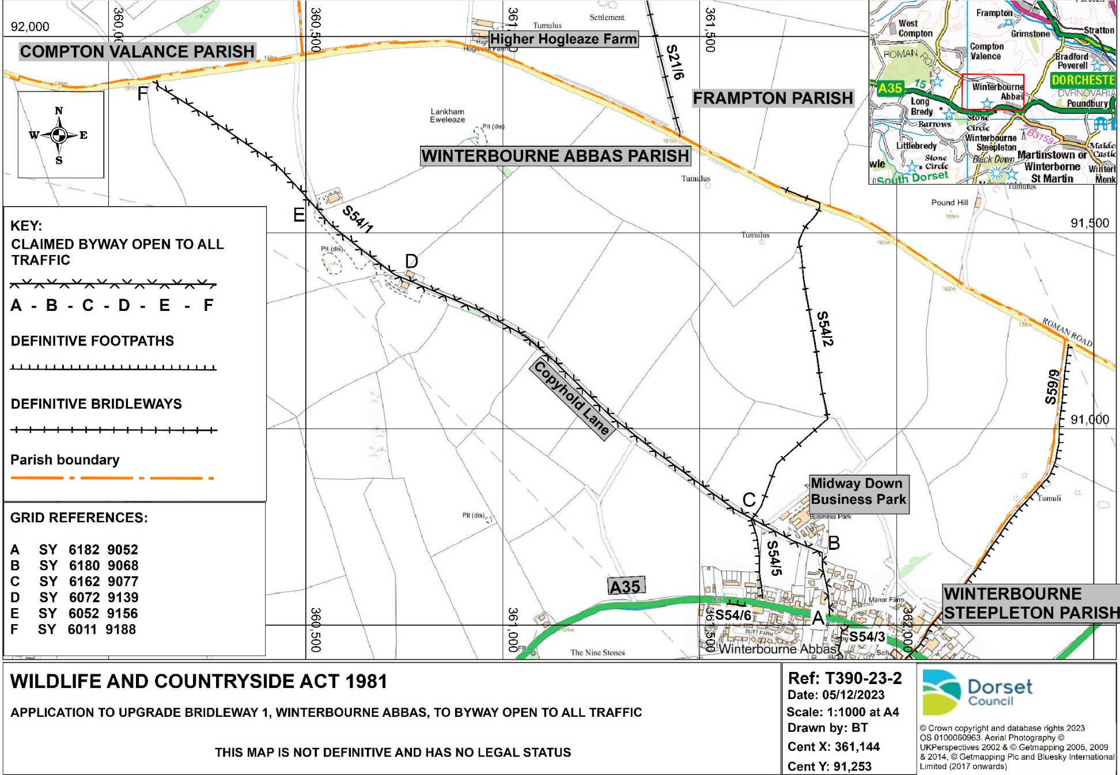
APPENDIX 1
LAW
APPENDIX 2

General
Wildlife and Countryside Act 1981
  - Section 53 of the Wildlife and Countryside Act 1981 requires that the Council keep the definitive map and statement under continuous review and in certain circumstances to modify them. These circumstances include the discovery of evidence which shows that a right of way not shown in the definitive map and statement subsists or is reasonably alleged to subsist.
  - Section 53 of the Act also allows any person to apply to the Council for an order to modify the definitive map and statement of public rights of way in consequence of the occurrence of certain events. One such event would be the discovery by the authority of evidence which, when considered with all other relevant evidence available to them, shows that a right of way not shown on the definitive map and statement subsists.
  - The Council must take into account all relevant evidence. They cannot take into account any irrelevant considerations such as desirability, suitability and safety.
  - For an application to add a right of way, the Council must make an order to modify the definitive map and statement if the balance of evidence shows either:
    - that a right of way subsists or
    - that it is reasonably alleged to subsist.
The evidence necessary to satisfy (b) is less than that necessary to satisfy (a).
  - An order to add a route can be confirmed only if, on the balance of probability, it is shown that the route as described does exist.
  - For an application to change the status of an existing right of way, the Council must make an order to modify the definitive map and statement if the balance of evidence shows that it ought to be recorded with that different status.
  - The confirmation test for an order to change the status of an existing right of way is that same as the test to make that order.
  - An order to add a right of way and change the status of an existing right of way as part of the same route should only be made if the balance of the evidence shows that the new route exists and the existing route should be recorded with a different status.
  - Where an objection has been made to an order, the Council is unable itself to confirm the order but may forward it to the Secretary of State for confirmation. Where there is no objection, the Council can itself confirm the order, provided that the criterion for confirmation is met.
- Highways Act 1980
  - Section 31 of the Highways Act 1980 says that where a way has been used by the public as of right for a full period of 20 years it is deemed to have been dedicated as highway unless there is sufficient evidence that there was no intention during that period to dedicate it. The 20 year period is counted back from when the right of the public to use the way is brought in to question.
    - ‘As of right’ in this context means without force, without secrecy and without obtaining permission.
    - A right to use a way is brought into question when the public’s right to use it is challenged in such a way that they are apprised of the challenge and have a reasonable opportunity of meeting it. This may be by locking a gate or putting up a notice denying the existence of a public right of way.
    - An application under Section 53 (5) of the Wildlife and Countryside Act 1981 for a modification order brings the rights of the public into question. The date of bringing into question will be the date the application is made in accordance with paragraph 1 of Schedule 14 to the 1981 Act.
  - The common law may be relevant if Section 31 of the Highways Act cannot be applied. The common law test is that the public must have used the route ‘as of right’ for long enough to have alerted the owner, whoever he may be, that they considered it to be a public right of way and the owner did nothing to tell them that it is not. There is no set time period under the common law.
  - Section 31(3) of the Highways Act 1980 says that where a land owner has erected a notice inconsistent with the dedication of a highway, which is visible to users of the path, and maintained that notice, this is sufficient to show that he intended not to dedicate the route as a public right of way.

  - Section 31 (6) of the Highways Act 1980 permits landowners to deposit with the Council a map and statement indicating what ways over the land (if any) he admits to having been dedicated as highways. A statutory declaration can be made at intervals of not more than 20 years stating no additional ways have been dedicated since the date of the deposit. In the absence of proof to the contrary, this is sufficient to establish that no further ways have been dedicated. Prior to the Highways Act 1980 a similar facility was available under the Rights of Way Act 1932 and the Highways Act 1959.
  - Section 32 of the Highways Act 1980 says that the Council must take into consideration any map, plan or history of the locality. Documents produced by government officials for statutory purposes such as to comply with legislation or for the purpose of taxation, will carry more evidential weight than, for instance, maps produced for tourists.
- Human Rights Act 1998
  - The criteria for definitive map modification orders are strictly limited to matters of fact and evidence. In all cases the evidence will show that the event (section53) has already taken place. The legislation confers no discretion on a surveying authority or the Secretary of State to consider whether or not a path or way would be suitable for the intended use by the public or cause danger or inconvenience to anyone affected by it. In such situations where the primary legislation offers no scope for personal circumstances to affect the decision on the order, the Planning Inspectorate’s recommended approach is to turn away any human rights representations.
  - A decision confirming an order made under the Wildlife and Countryside Act 1981 would be lawful (under domestic law) as provided by Section 6.2 of the Human Rights Act 1998 even in cases where the Convention was apparently infringed, where it was impossible to interpret the 1981 Act in such a way that it is compatible with the Convention rights (section 3 Human Rights Act 1998).
- Finance Act 1910
  - The Finance Act 1910 required the Commissioners of Inland Revenue to cause a valuation of “all land in the United Kingdom” and plans were prepared identifying the different areas of valuation. In arriving at these valuations certain deductions were allowed, including deductions for the existence of public rights of way.
  - Public ‘fenced’ roads were generally excluded from the valuation. Where public rights passed through, for example a large field and were unfenced, they would be included in the valuation and a deduction would be made in respect of the public right of way.
- National Parks and Access to the Countryside Act 1949
  - The National Parks and Access to the Countryside Act 1949 required the County Council as “Surveying Authority” to compile the record of the public rights of way network and the District and Parish Councils were consulted to provide the County Council with information for the purposes of the survey
- Natural Environment and Rural Communities Act 2006
  - Section 67 of the Natural Environment and Rural Communities Act 2006 (NERC) extinguishes (subject to certain exceptions) unrecorded rights of way for mechanically propelled vehicles. DEFRA guidance states that where it is found that a route was historically a public vehicular route before NERC, that route should be recorded as a restricted byway rather than a byway open to all traffic.

DOCUMENTARY EVIDENCE CONSIDERED
APPENDIX 3

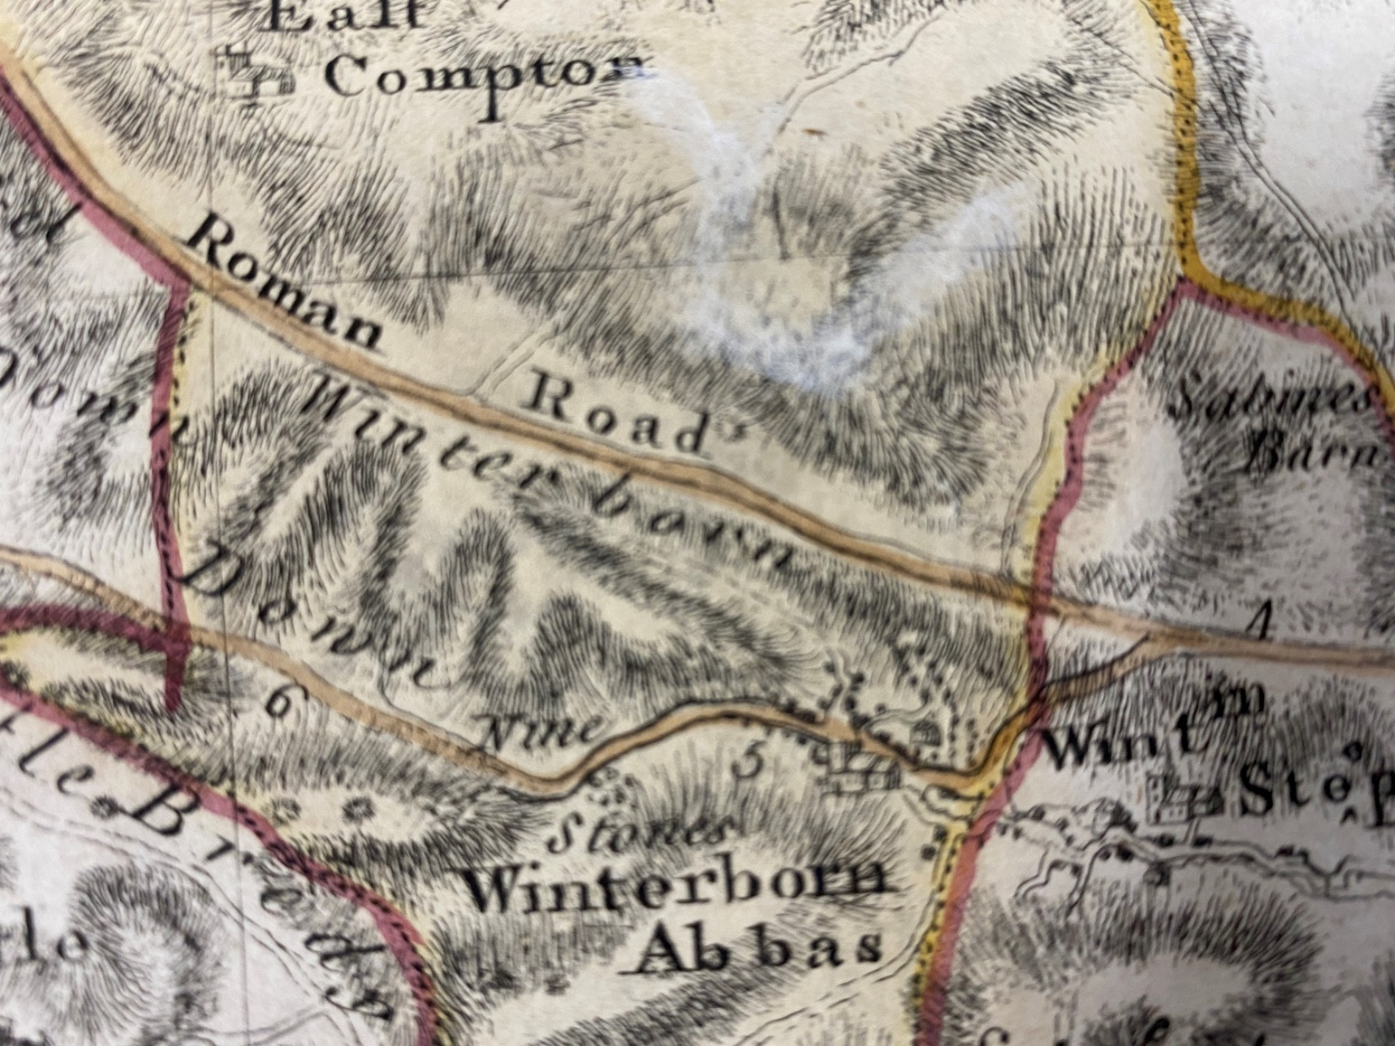
Taylor 1765 extract
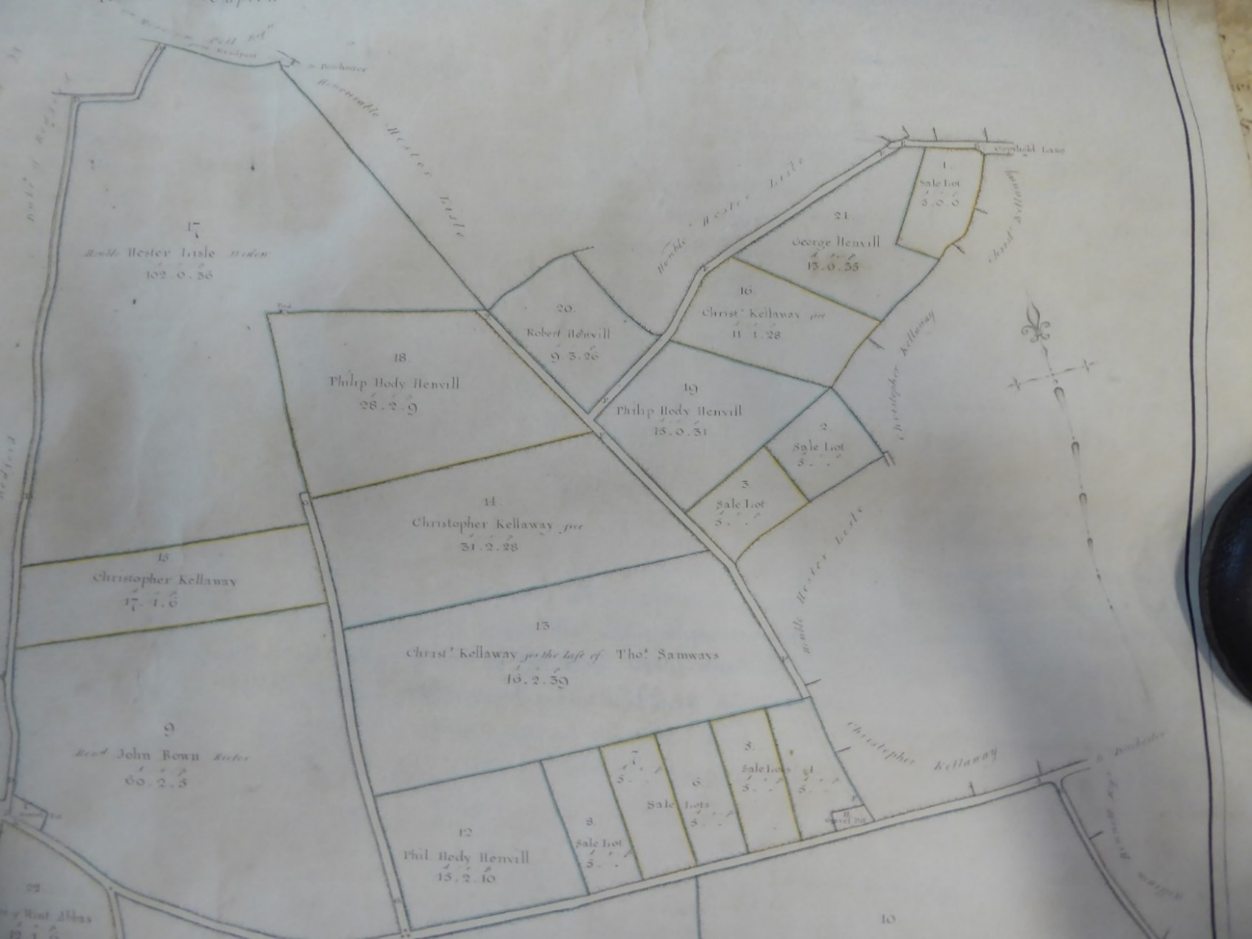
1808 Inclosure Award map extract

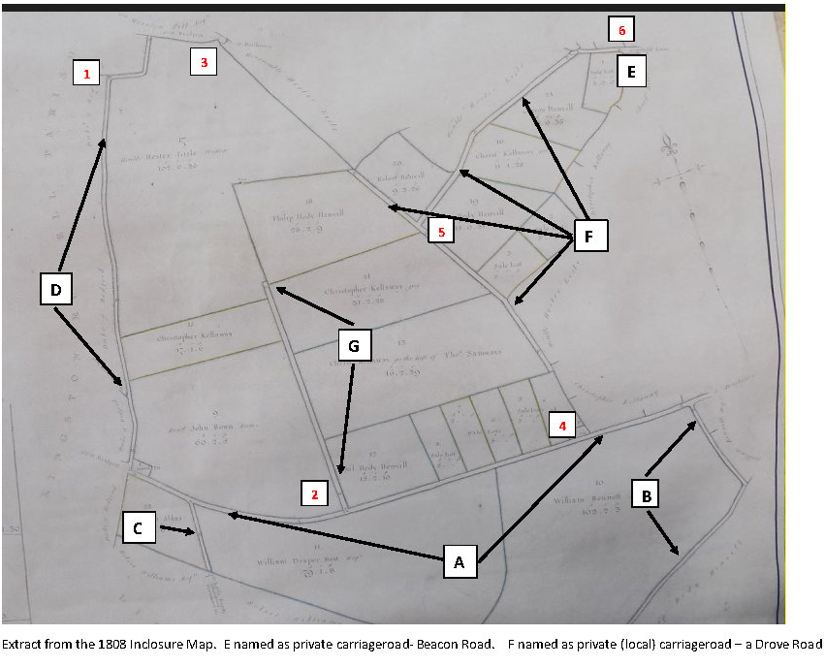
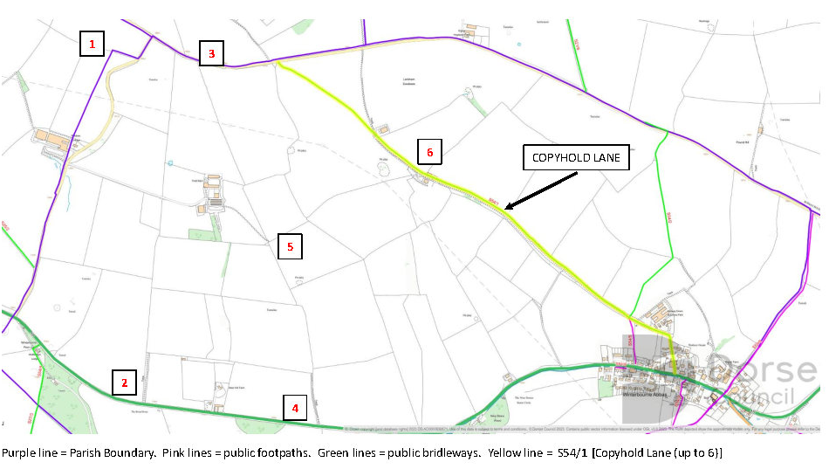

Comparison of Inclosure map with Ordnance Survey map – corresponding numbers

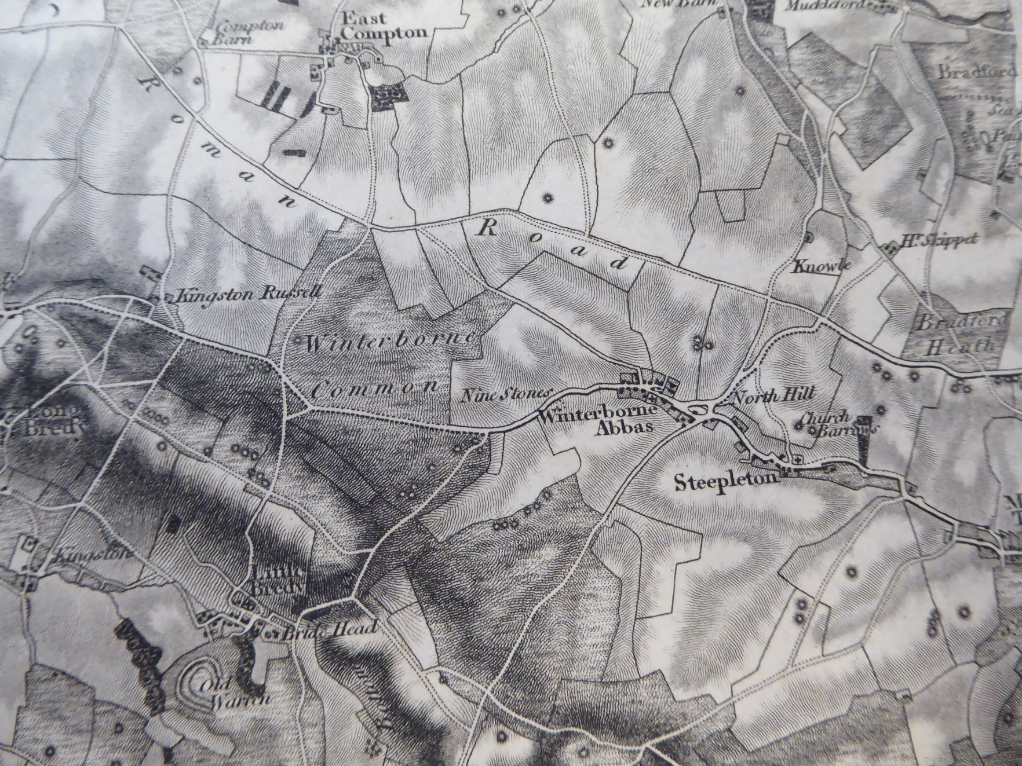
Mudge Map 1817 extract
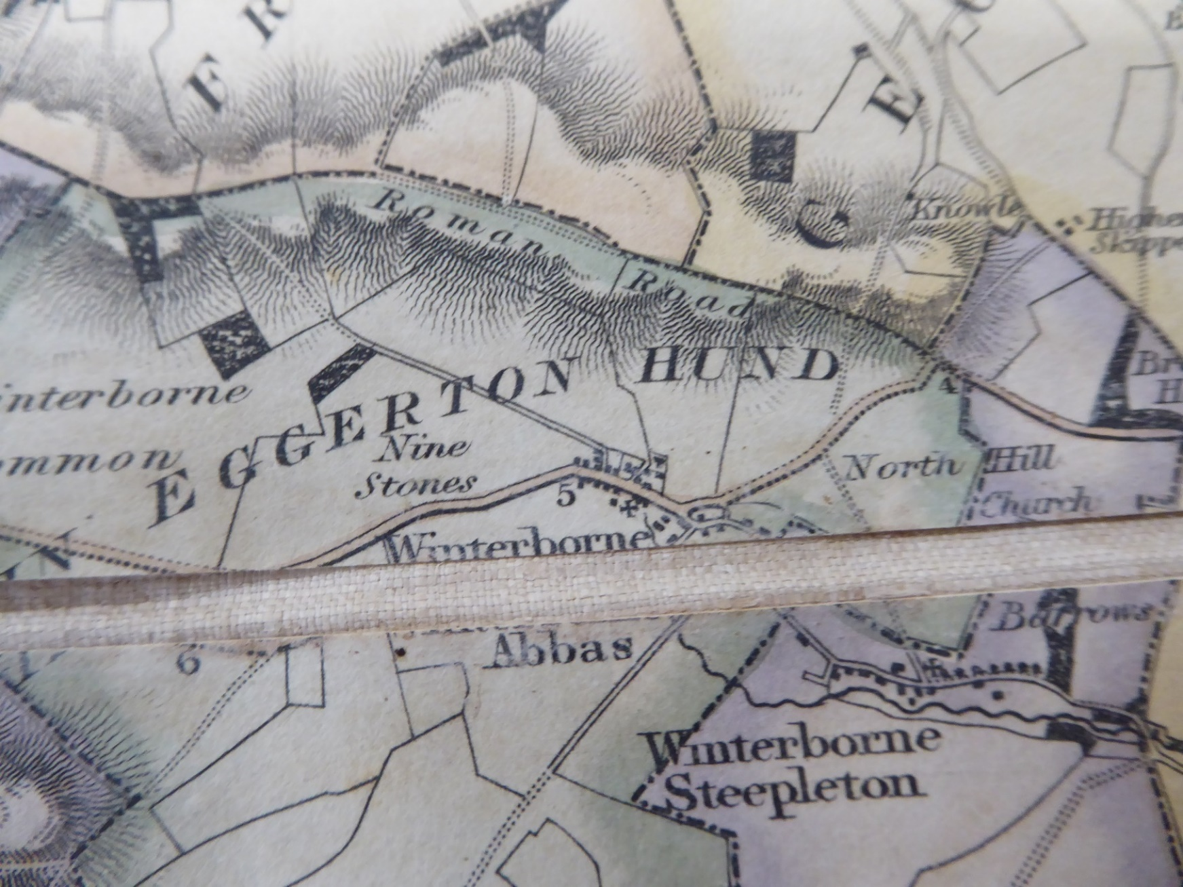
1826 Greenwoods Map extract
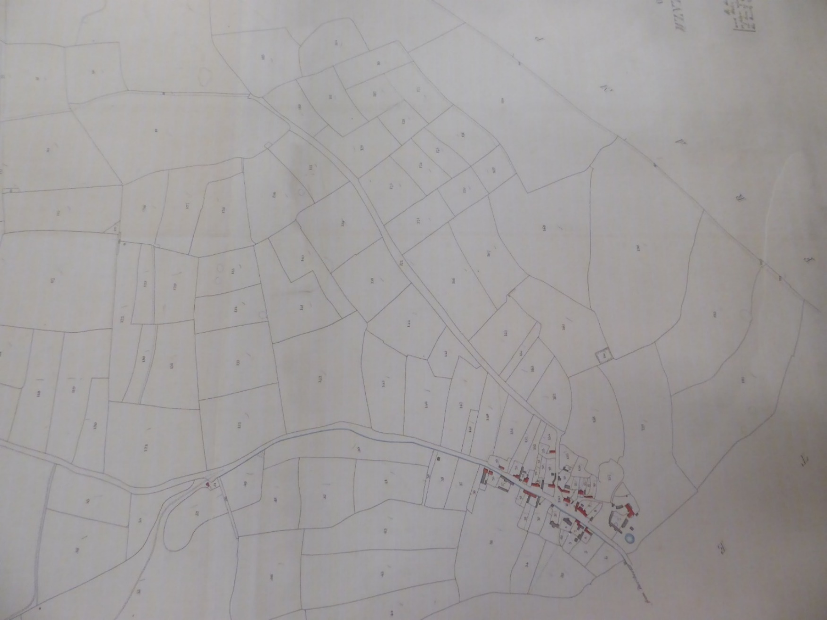
Apportionment 172
Apportionment 88
D
E
A
C
B
1840 Tithe Map extract
1888 Ordnance Survey 25 inch to one mile
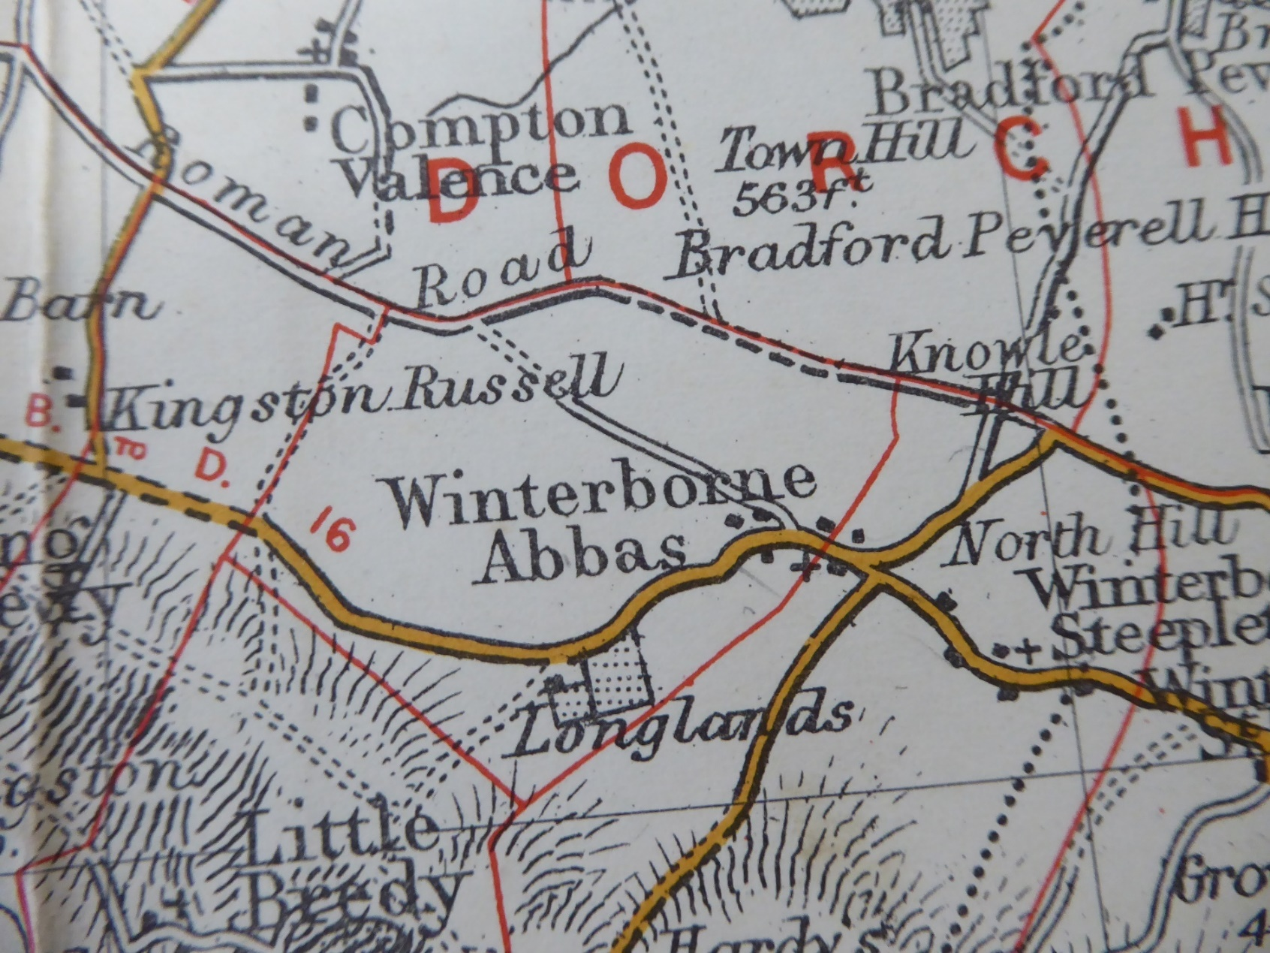
1895 – Bacon’s geographical map
1903 Ordnance Survey - Six inch to one mile
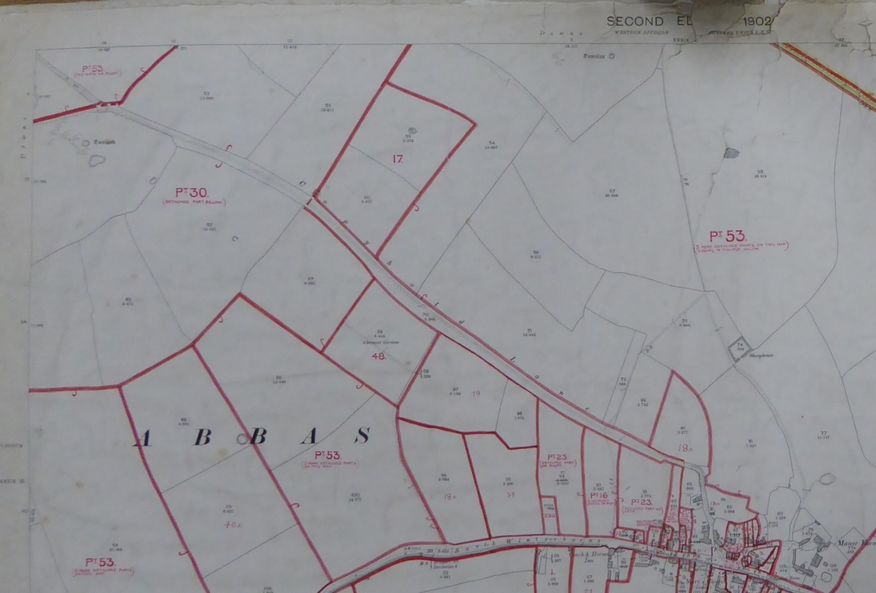
Hereditament
18(pt)
A
B
C
D
Hereditament 53(pt)
Hereditament 30(pt)
1910 Finance Act plan - Southern section of Claimed Route – A-B-C-D

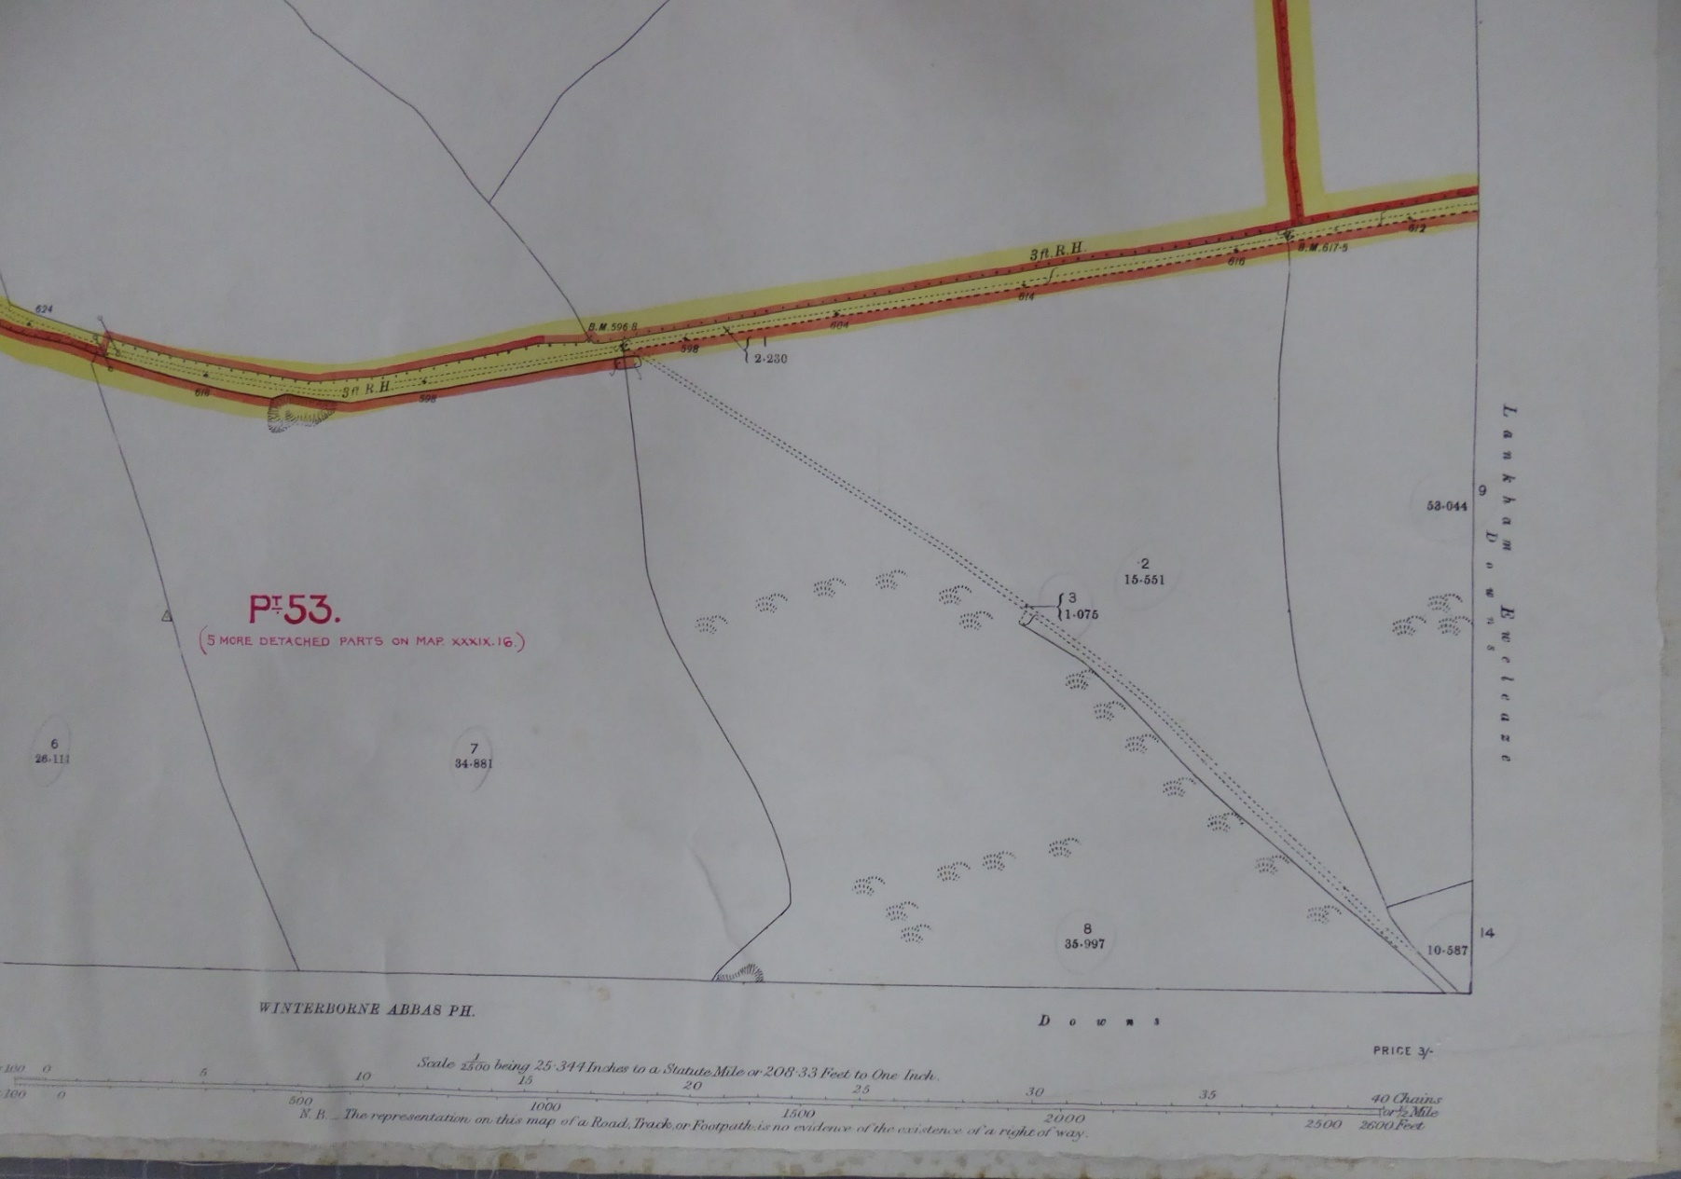
E
F
Hereditament 53(pt)
1910 Finance Act map - Northern section – E-F

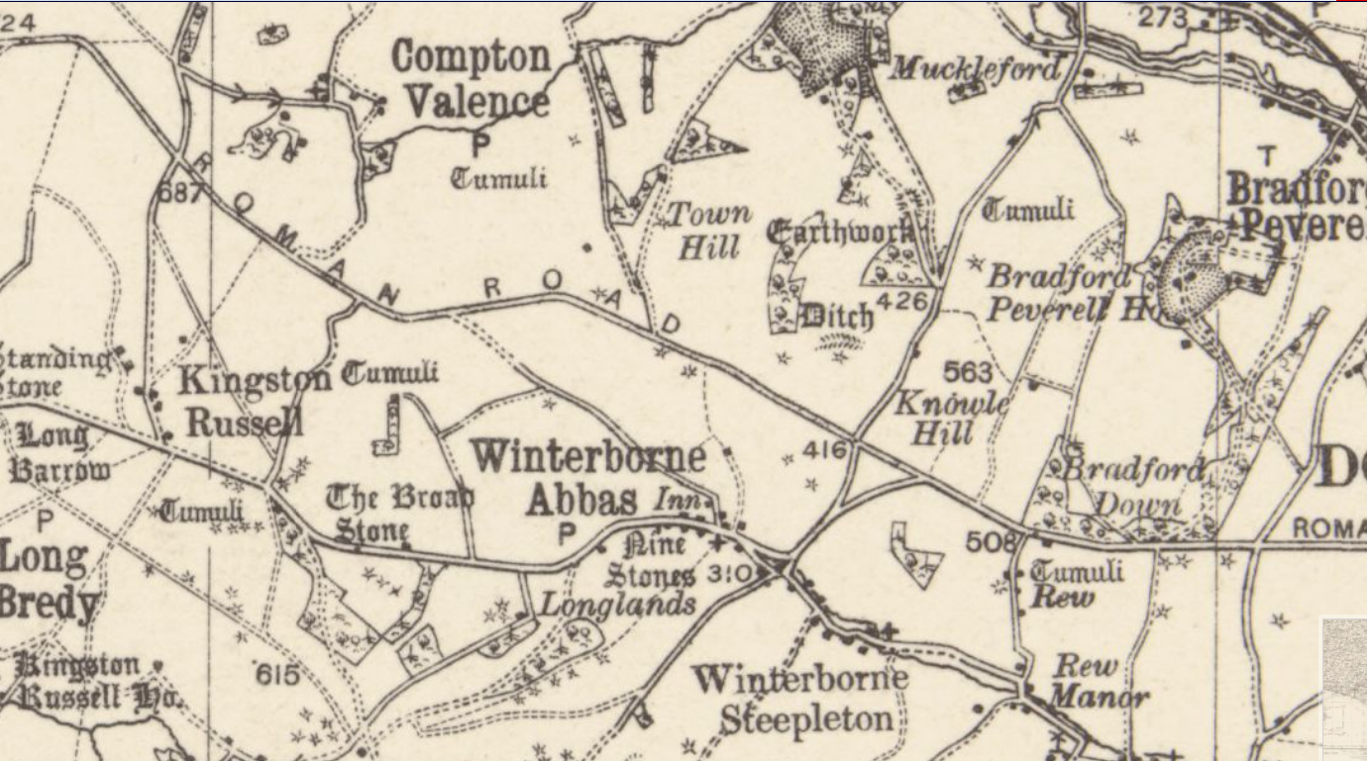
1928 Ordnance Survey - Half inch to the mile
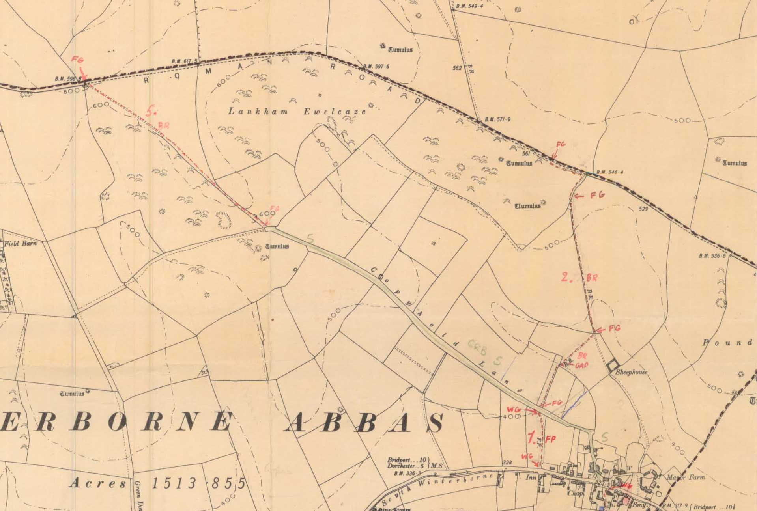
1952 Parish Survey – Winterbourne Abbas

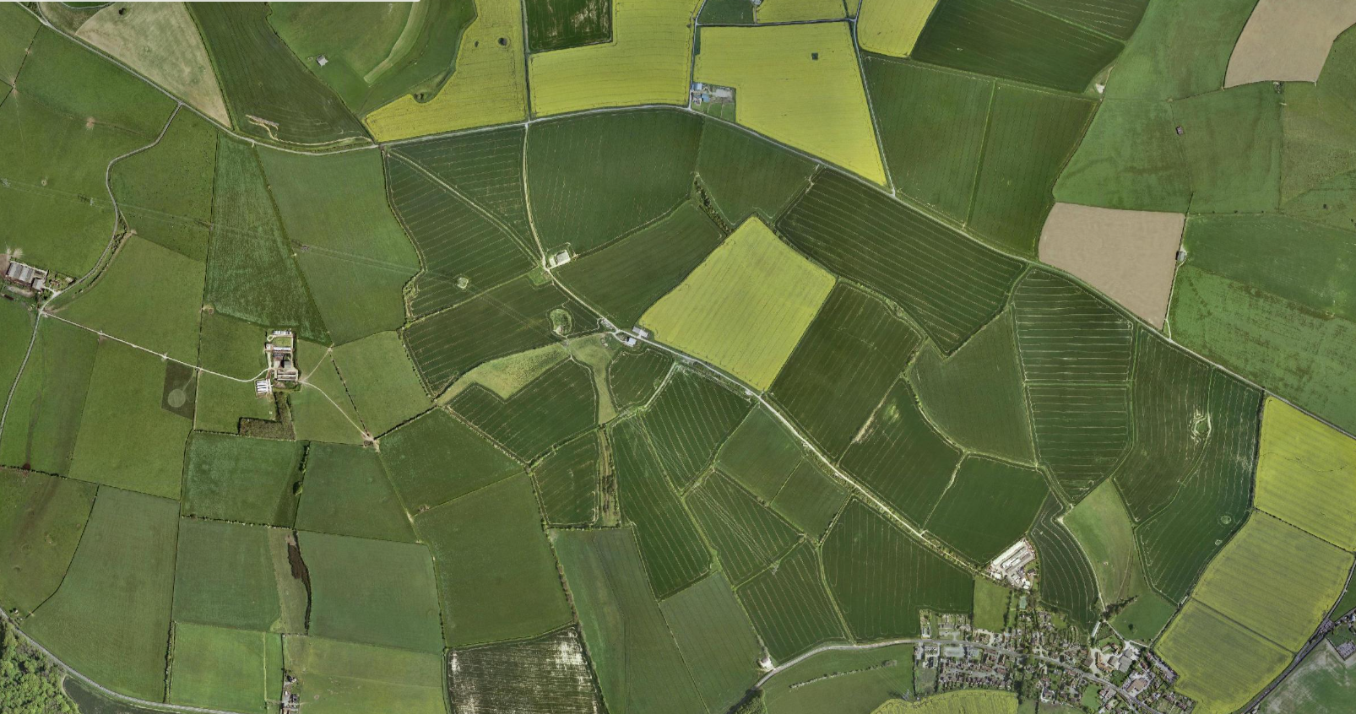
F
E
D
C
A
B

2002 Aerial photograph

Recommendations accepted:

Signed:

……V Penny………….. Date:………… 2023…
Vanessa Penny
Definitive Map Team Manager
Spatial Planning

